|  |  |
| --- | --- |
|  | FPT ACADEMY INTERNATIONAL  FPT – APTECH COMPUTER EDUCATION |

Centre Name: ACE-HCMC-2-FPT.

Address: 590 Cach Mang Thang 8, District 3, Ho Chi Minh City, Viet Nam.

**[Amazing Astronomy]**

|  |  |  |
| --- | --- | --- |
| Supervisor: | Phạm Thị Lánh | |
| Term: | 1 | |
| Batch No: | T1.2212.E1 | |
| Group No: | 6 | |
| Order: | Full name | Roll No. |
| 1. | Nguyễn Gia Bảo | Student1438968 |
| 2. | Trần Bình Nguyên Bách | Student1438970 |
| 3. | Phan Thành Nhân | Student1438986 |
| 4. | Trương Trung Dũng | Student1448979 |

Month 04 Year 2022

This is to certify that

**Mr. Nguyễn Gia Bảo**

**Mr. Trần Bình Nguyên Bách**

**Mr. Phan Thành Nhân**

**Mr. Trương Trung Dũng**

Have successfully Designed & Developed

**AMAZING ASTRONOMY**

Submitted by: **Ms. PHAM THI LANH**

Date Of Issue: April, 2022

Authorized Signature:

# Content

Content 3

Acknowledge 5

Synopsis 6

REVIEW 1 7

Problem Definition 8

Architecture and Design of the project 10

Site map 10

Website Design Layout 11

I. Homepage 12

II. Star Gazing 13

III. Planet 13

IV. Star and Asteroid 14

V. Constellation 15

VI. History 15

VII. Contact 16

Task Sheet 17

REVIEW 2 18

WEBSITE USER INTERFACE 19

I. Homepage 20

II. Star Gazing 21

III. Planet 22

IV. Star and Asteroid 23

V. Constellation 25

VI. History 26

VII. Contact 27

Task Sheet 28

Testing document 29

Final checklist 30

# Acknowledge

We recognize that the eProject is a progressive learning environment that closely replicates the traditional classroom and lab-based learning experiences for real-world implementation. It is an electronic, live platform that enables users to:

* Practice step-by-step using a laddered approach
* Develop larger, more robust applications
* Use specific utilities in user-designed applications
* Unify code for a comprehensive application using a single program
* Learn implementation of concepts progressively
* Enhance skills and value
* Work on real-life projects
* Create complex and useful applications using real-life scenarios
* Receive mentoring through email support.

We extend our gratitude to our professor and fellow students for their valuable support throughout the project. Despite making several mistakes, we look forward to additional opportunities to expand our knowledge in web development. We also express appreciation for the information and "demo" project provided by India APTECH, which gave us a realistic experience in this project. Having gained further experience, we are committed to continuing our learning to achieve greater success in the future.

Sincerely,Your Sincerely,

Team Group 06.

# Synopsis

- The Objective of this program we aim is to give a sample project to work on real life projects. These applications help us build a larger, more robust application.

- The objective is not to teach us HTML/JavaScript but to provide us with a real life scenario and help us create basic applications using the tools.

- Hence, we can revise the chapters before we start with the project.

- This project The Objective of this program is to give a sample project to work on real life projects. These applications help you build a larger, more robust application.

- The objective is not to teach you the software but to provide you with a real-life scenario and help you create basic applications using the tools.

- You can revise the topics before you start with the project.

- This project is meant for students who have completed the module of HTML5.

- These programs should be done in the Lab sessions with assistance of the faculty if required.

- The website (in this project) is a tool that help the company to access the

international market and gain more and more new customers.

- It is very essential that a student has a clear understanding of the subject.

# REVIEW 1

## Problem Definition

The problem at hand is to develop a user-friendly website that provides information about astronomy. The website should be designed to offer a seamless navigation experience to the users. It should contain brief details about the sun, moon, stars, and planets, which will be a source of wonder for many people.

The website should have an easy-to-use interface that provides important menu options in the top section of the webpage. The design of the website should be visually appealing and must have an attractive color combination.

To meet these requirements, a Single-Page-Application and responsive website should be created using HTML5, JSON, JavaScript and Geolocation technologies. The website should be compatible with all leading web browsers, including Chrome, Internet Explorer, and Firefox.

Overall, the problem statement aims to develop a website that will serve as a one-stop solution for people who are interested in astronomy. The website should be designed to provide a visually appealing and seamless user experience, making it easier for users to access information about astronomy.

Here are some problems need to be resolved:

1. User Interface Design: The website needs to be user-friendly with a clean and attractive layout, easy navigation, and the menu should be placed in a prominent location. The design should also be responsive, so it works well on different devices and screen sizes.

2. Functionality: The website needs to function properly and provide users with accurate information. This includes implementing Geolocation to provide location-specific information.

3. Compatibility: The website needs to be compatible with all major browsers, including Chrome, IE, and Firefox.

4. Performance: The website should be optimized for fast load times and smooth performance, even when accessing large amounts of data or interactive features.

5. Content Quality: The content of the website should be informative, accurate, and engaging for users. It should also be regularly updated to keep up with the latest information and discoveries in astronomy.

6. Security: The website should be secure and protect user data, including any personal or sensitive information collected through Geolocation.

7. Technical Expertise: The development team needs to have the technical expertise to develop a Single-Page-Application using HTML5, JSON, Angular JS, and JavaScript. They should also have experience working with Geolocation technology.

## Architecture and Design of the project



## Site map

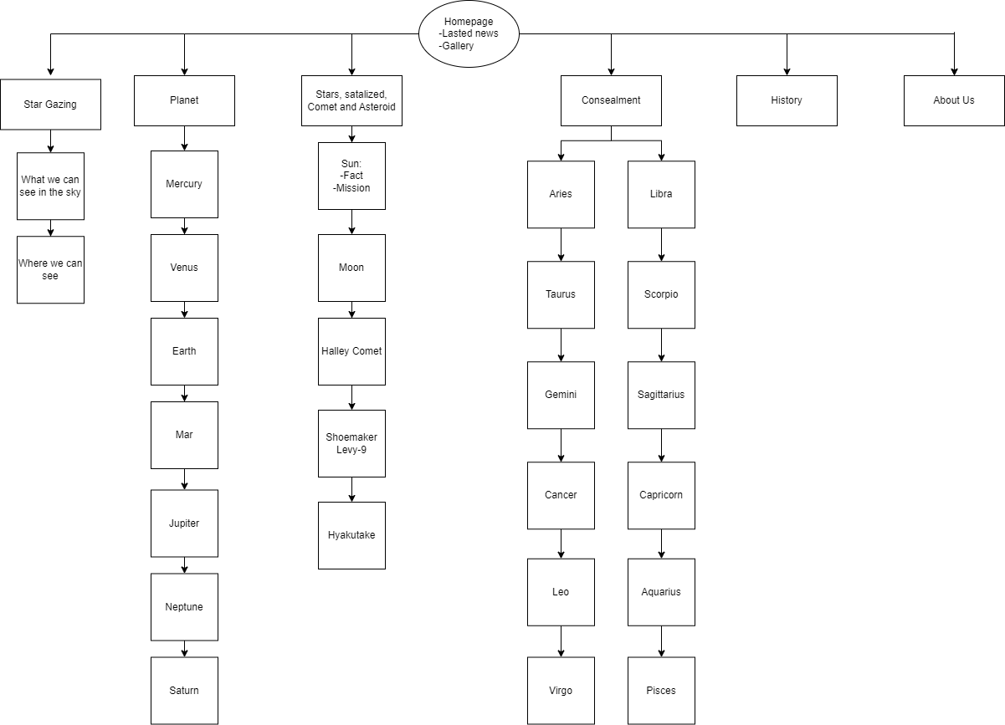

## Website Design Layout

### Homepage

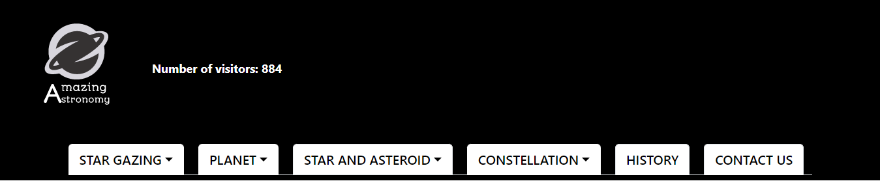

**Description:** This is the homepage of Amazing Astronomy. The header is an important element of the homepage as it is the first thing users will see when they visit the site. It includes the logo used as a homepage button and number of visitors visit the page. The navigation bar will make it easy for users to explore the site and find the information they are looking for. In the navigation bar will have fade in fade out effect, the text also change color when hover on as well as clicking.

The main part of the homepage includes two sections, the latest news and galleries. The latest news section can include articles, blog posts, or other content that is relevant to the company's mission or industry. The galleries section can include images or videos that showcase the company's products, services, or events. These sections will help users to engage with the company and stay informed about its activities.

The footer of the homepage includes two sections. The first section provides information about the Sky Gazing company, such as its address, phone number, and email address. This information will help users to contact the company if they have any questions or concerns. The second section is a scrolling ticker that displays the day, time, and user location. This feature can be helpful for users who want to stay up-to-date on current events or time-sensitive information.

### Star Gazing

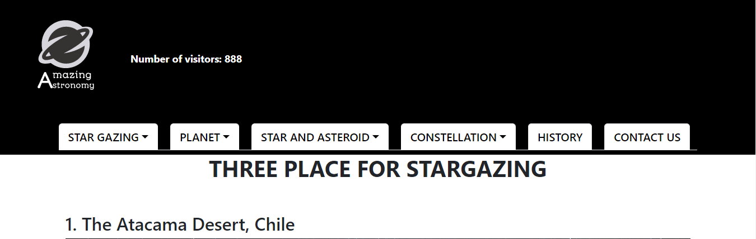

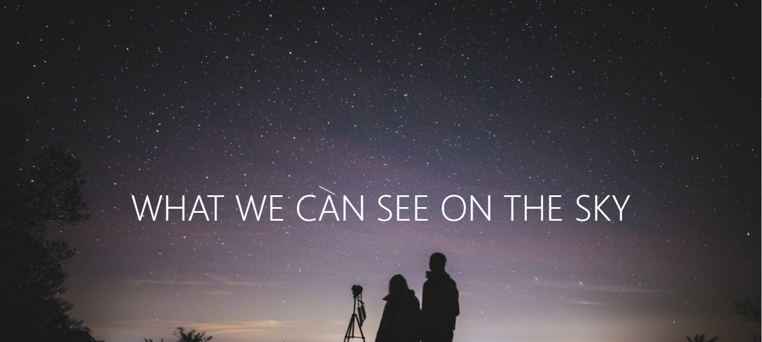

**Description:**

The first page is dedicated to what users can see in the sky. This section can include information about constellations, planets, and other celestial objects that are visible to the naked eye. This information can be a great motivator for users to explore further and learn more about astronomy and the night sky.

The second page is dedicated to where users can find the best places to practice star gazing. This section include information about local parks, nature reserves, and other areas that are free from light pollution and offer clear views of the night sky.

### Planet

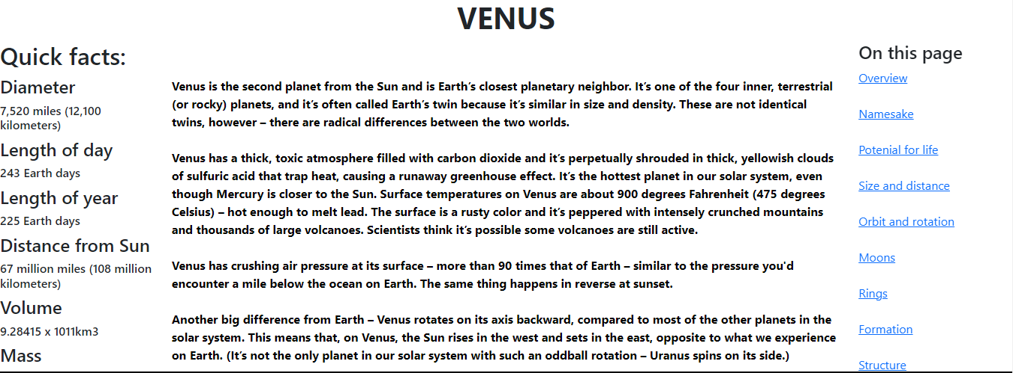

**Description:** When the user clicks on the planet button they can see a category of planet in the solar system,

The page for each planet is divided into three parts. The first part is the quick fact, which gives the user a brief overview of the planet's key characteristics, such as its distance from the sun, size, and composition. This information is presented in a concise and easily digestible format, allowing users to quickly get a sense of what the planet is like.

The second part of the page is the main part, which provides users with detailed information about the planet. This section can include information about the planet's history, geology, atmosphere, moons, and any other relevant details. It's important to present this information in a clear and organized way, so that users can easily find the information they're looking for.

Finally, there is a menu that allows users to navigate quickly to the part of the part that they are most interested in. This is an important feature because it helps users to find the information they need quickly and easily, without having to scroll through the entire page.

### Star and Asteroid

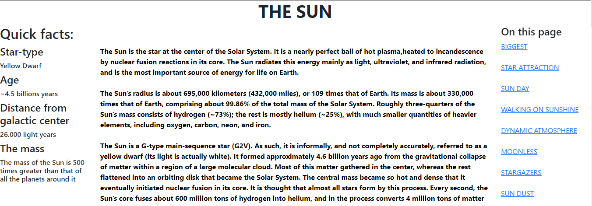

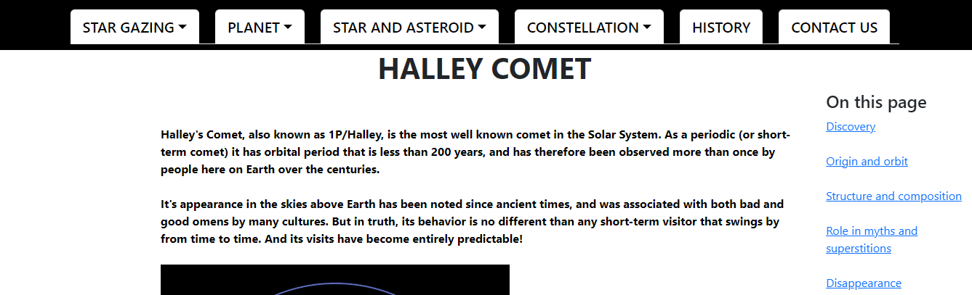

**Description:** In this section we will include stars and asteroid. First of all, we plan to start with the Sun, the only star in the solar system, and follow with information about the Moon in the same style as the planet section

For asteroids, it is understandable that there is less information available, so focusing on the main information and providing a menu for users to navigate to specific areas of interest is a great approach.

### Constellation

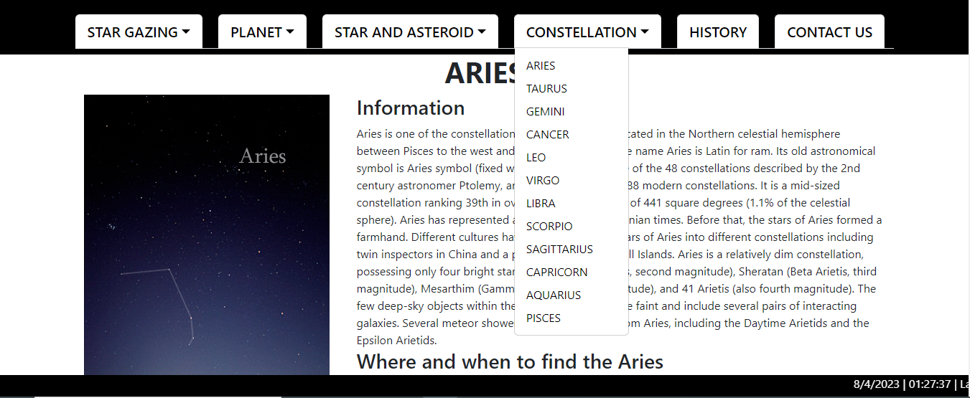

The Constellation page is an exciting feature of Sky Gazing Company's website that allows users to explore and learn about the different constellations visible in the night sky. The constellation page will provide users with detailed information on different constellations, including their history, mythology, and scientific significance. Users can click on a list of constellations to find the ones that interest them most.

### History

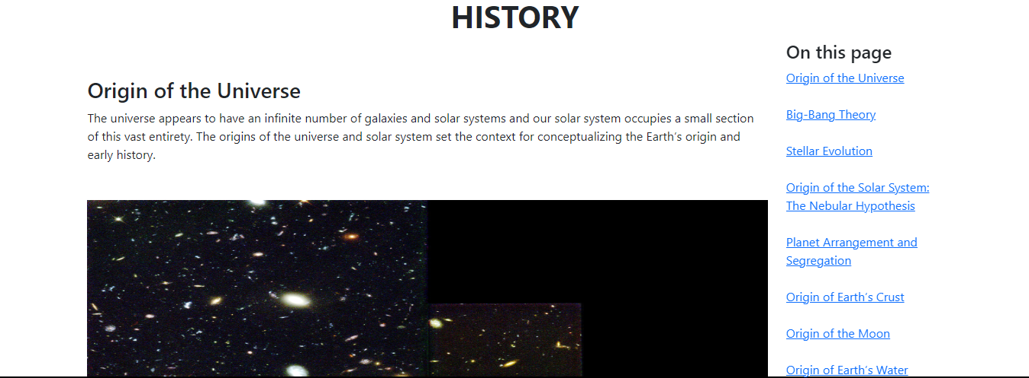

**Description:** The history section in the website, which providing a timeline of the universe's history is a fantastic way to give users a sense of the scale and complexity of the cosmos.

### Contact Us

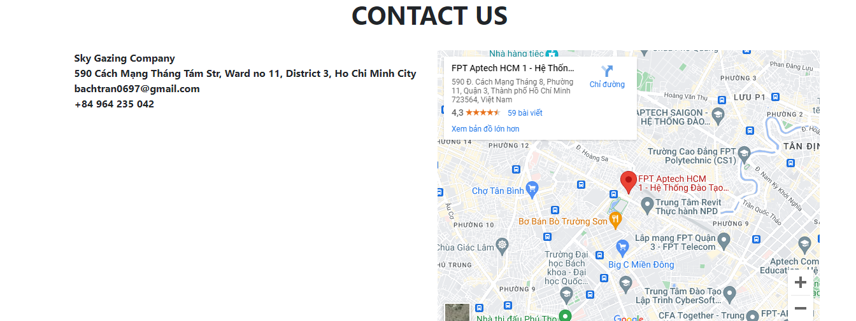

**Description:** If users click on the Contact tag in the navigation bar, they will be taken to a page where they can find detailed information on how to contact Sky Gazing Company. The first part of the page will include a map that shows the location of the company. The map will be interactive, allowing users to zoom in and out and view the location in different ways.

Beside the map, users will find a detailed description of the company's location, including the street address, city, state, and ZIP code. This information will be useful for users who want to visit the company in person, as well as for those who need to send mail or packages.

## Task Sheet

|  |  |  |  |  |  |  |
| --- | --- | --- | --- | --- | --- | --- |
| **Project Ref No.** | **Project Title – Ask Me Mobile** | **Activity Plan Prepared by** | **Date of preparation of Activity Plan** | | | |
| **Task** | **Actual Start Date** | **Actual Days** | **Teammate Names** | **Status** |
| Brainstorming ideas for layouts and Project Object | | Bách, Nhân, Dũng, Bảo | 11/03/2023 | 1 days | Bách, Nhân, Dũng, Bảo | Completed |
| Draw site maps and architecture design | | Bách, Nhân | 11/03/2023 | 1 days | Bách, Nhân | Completed |
| Wire framing general page layout | | Bách | 13/03/2022 | 3 days | Bách | Completed |
| Collect static assets (pictures, mp4, documentation,…) | | Bách, Nhân, Dũng, Bảo | 13/03/2022 | 5 days | Bách, Nhân, Dũng, Bảo | Completed |

# REVIEW 2

# WEBSITE USER INTERFACE

### Homepage

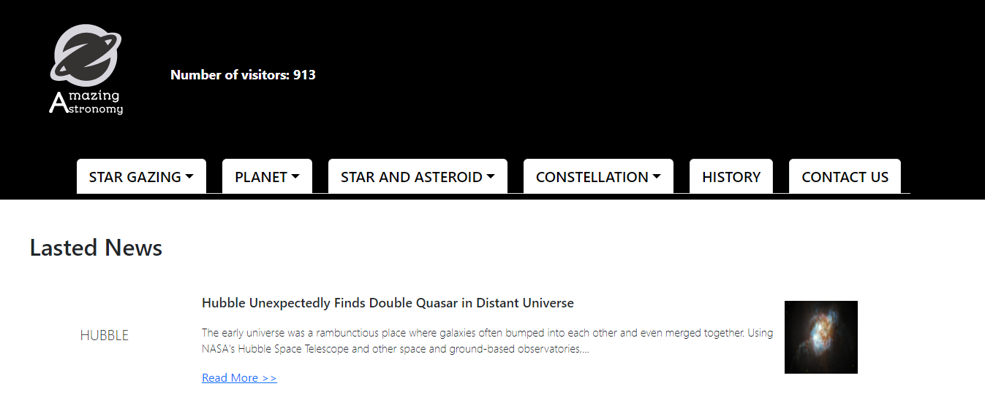

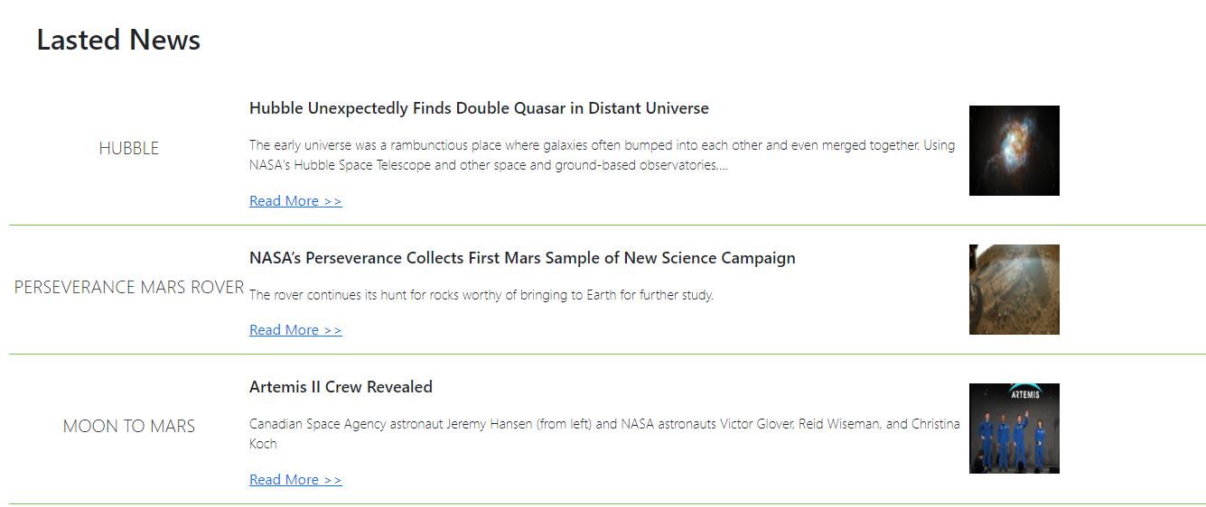

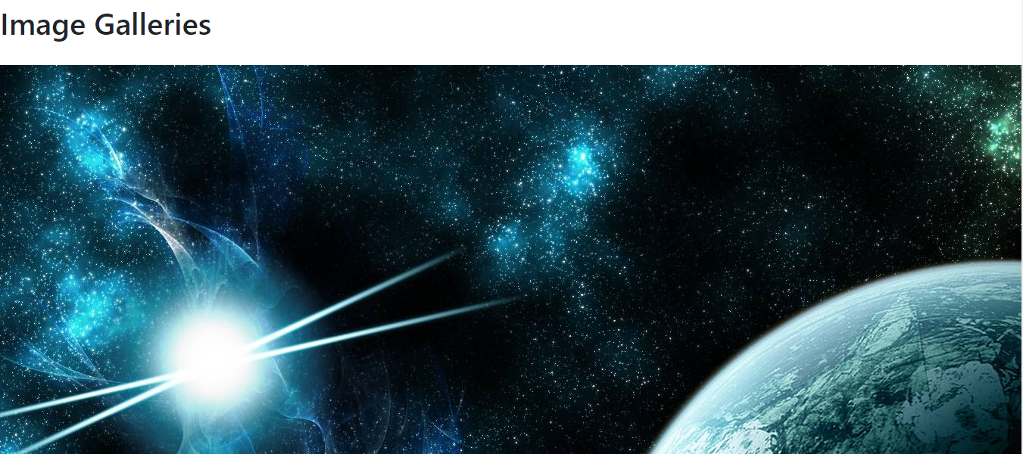

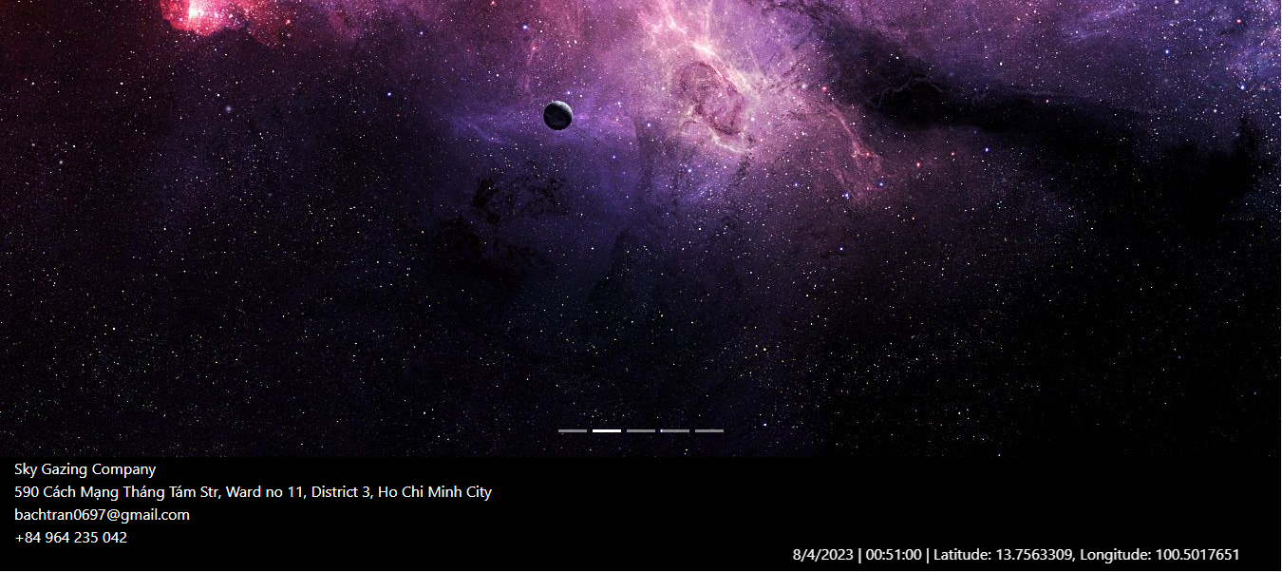

### Star Gazing

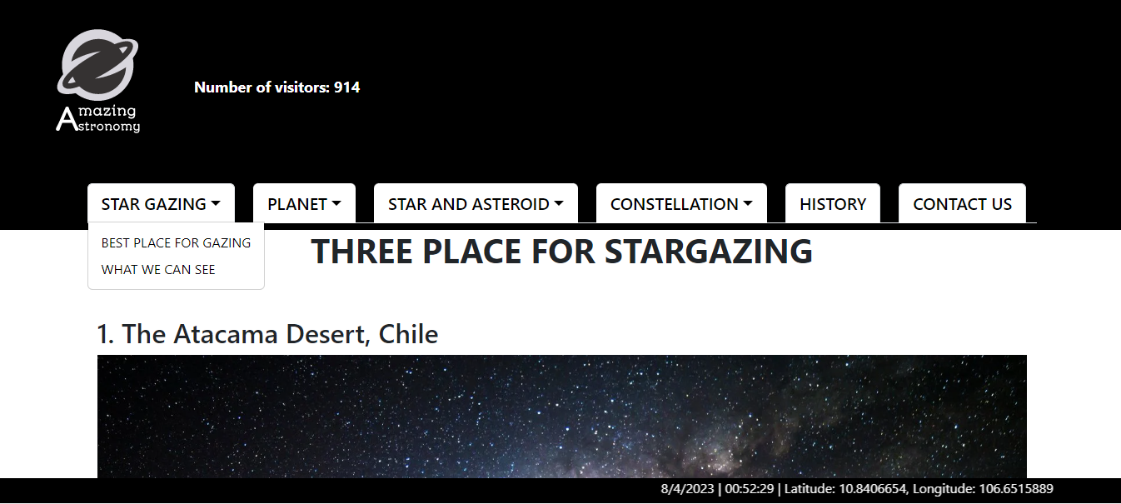

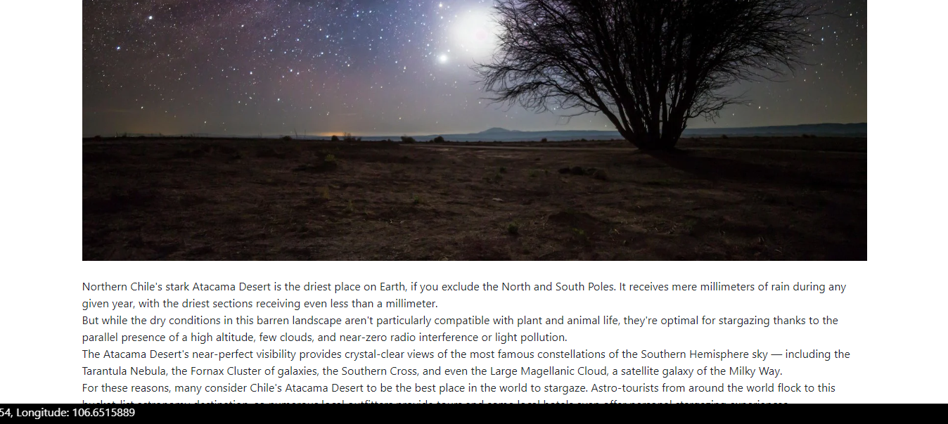

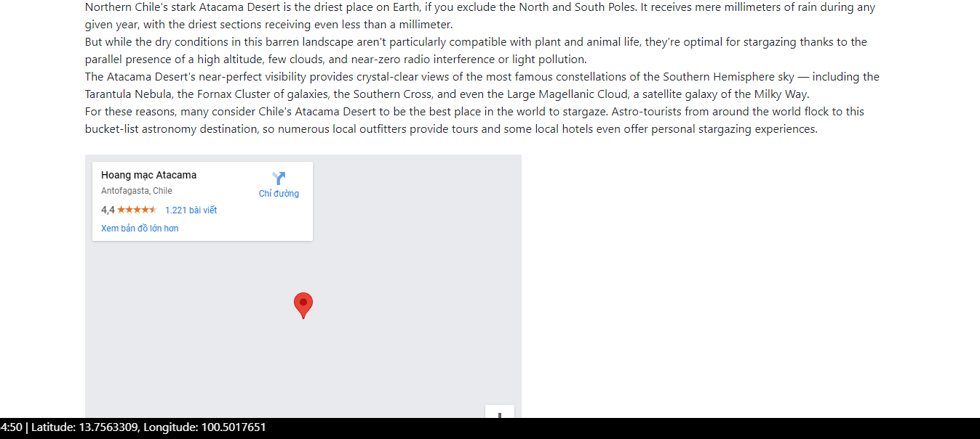

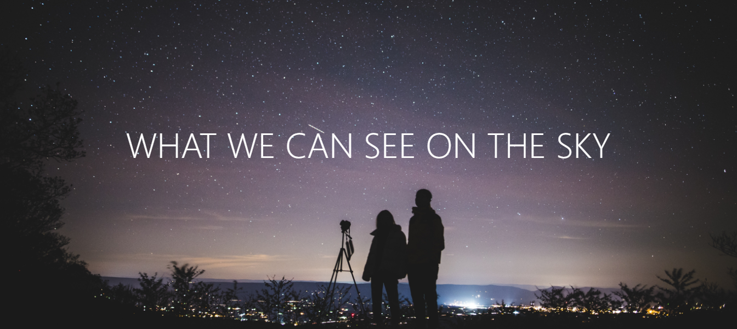

### Planet

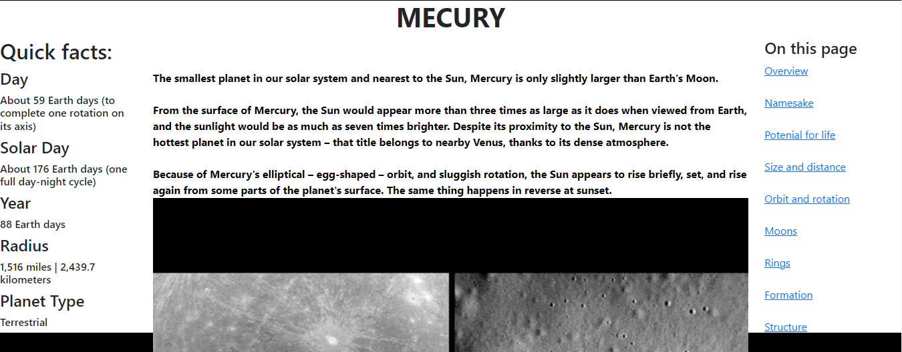

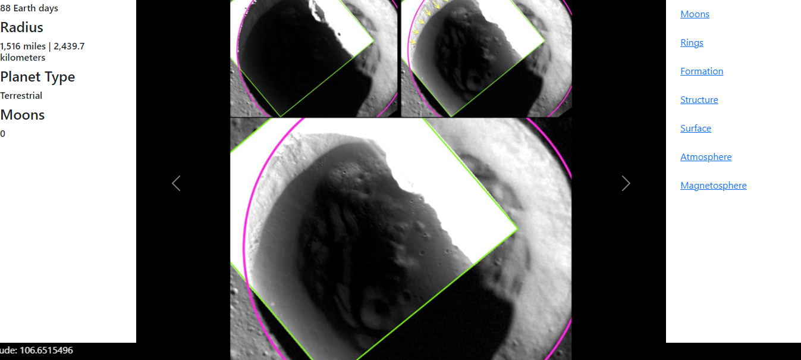

### Star, Asteroid

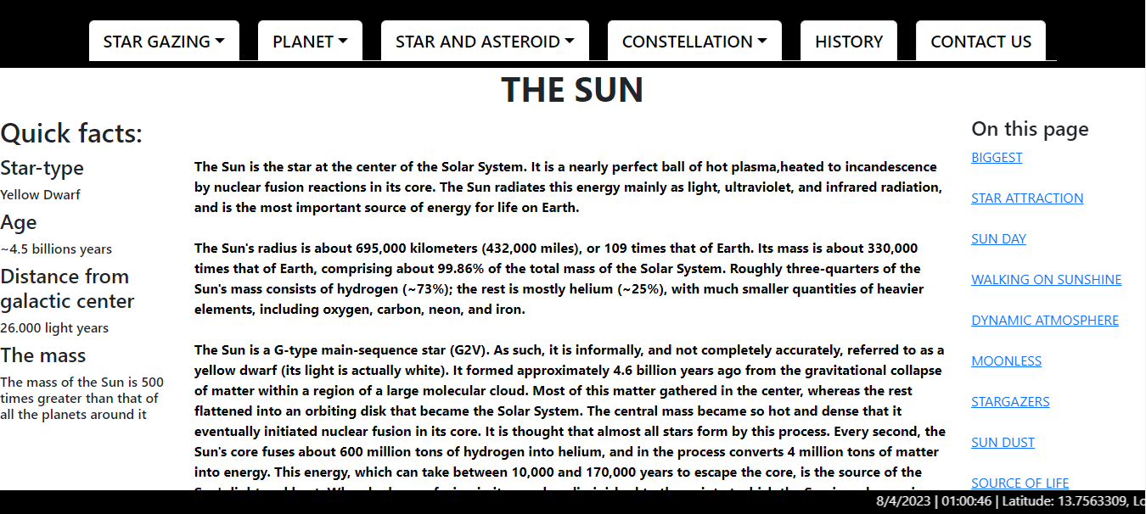

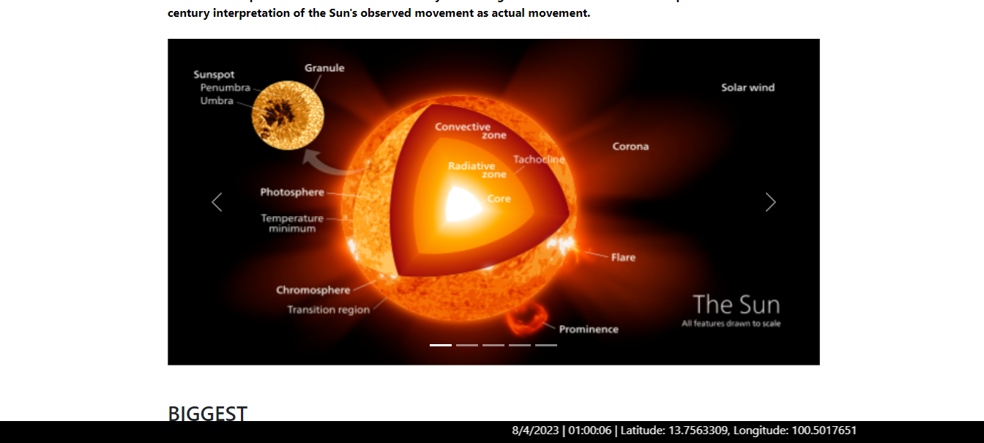

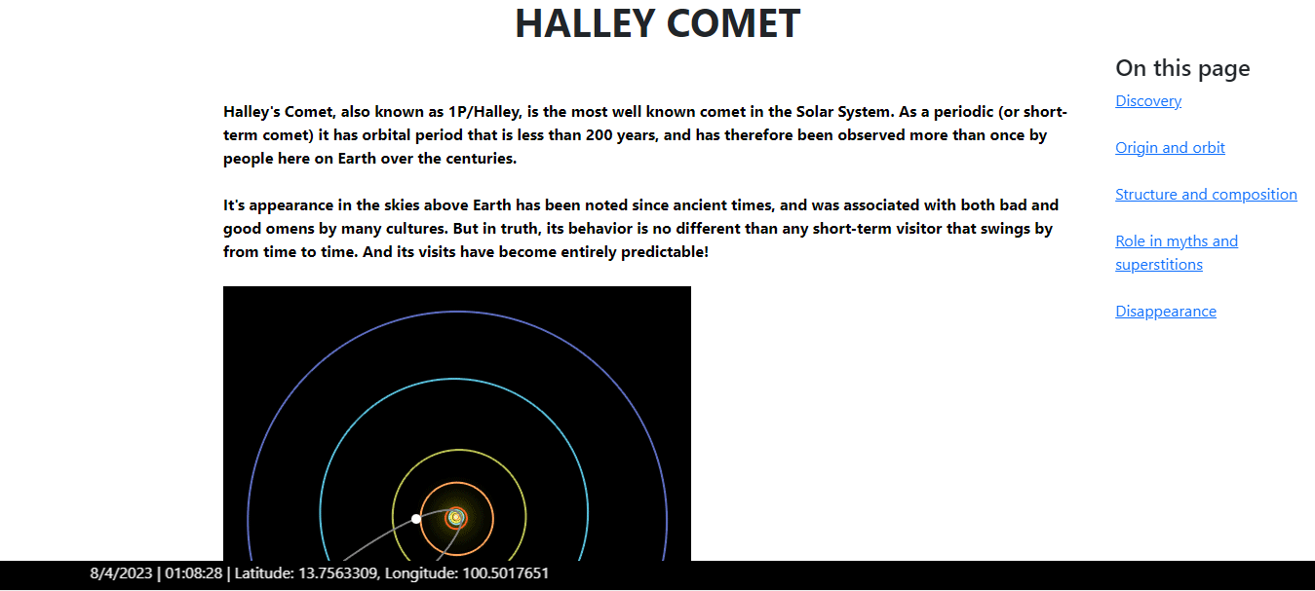

### Constellation

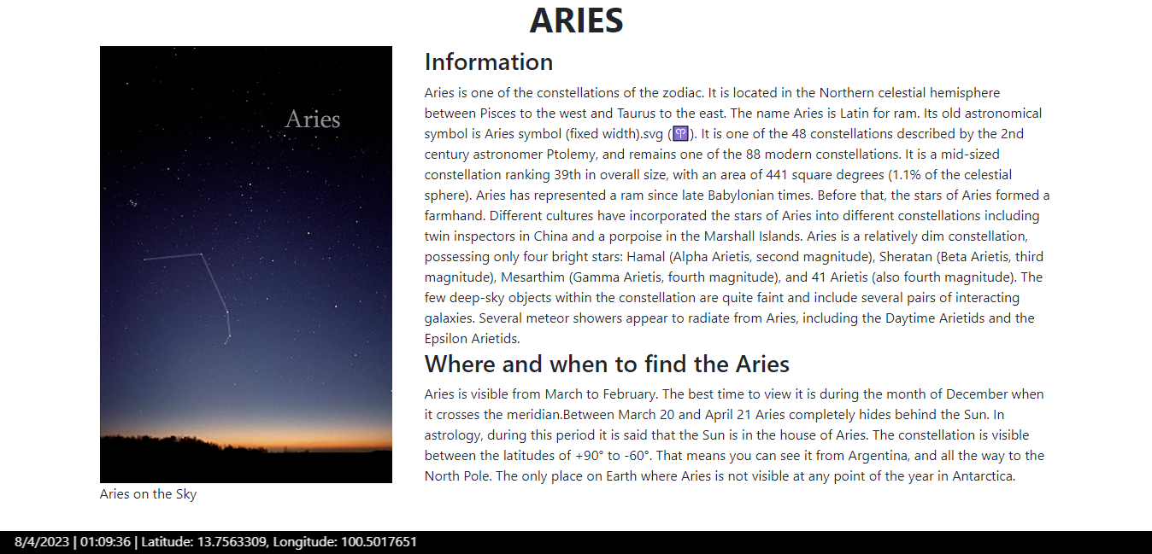

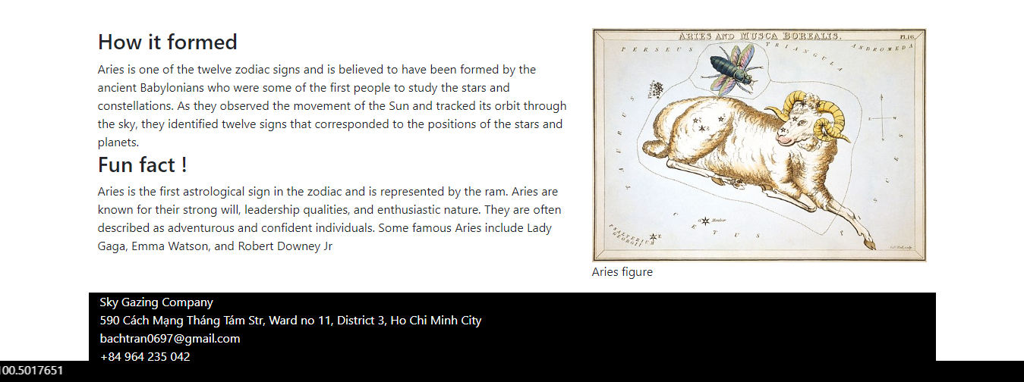

### History

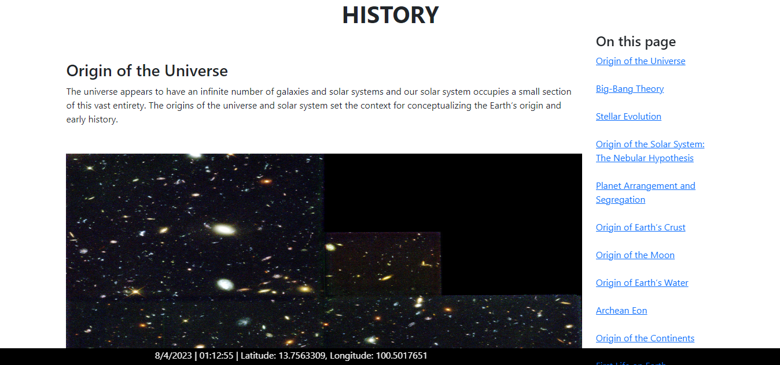

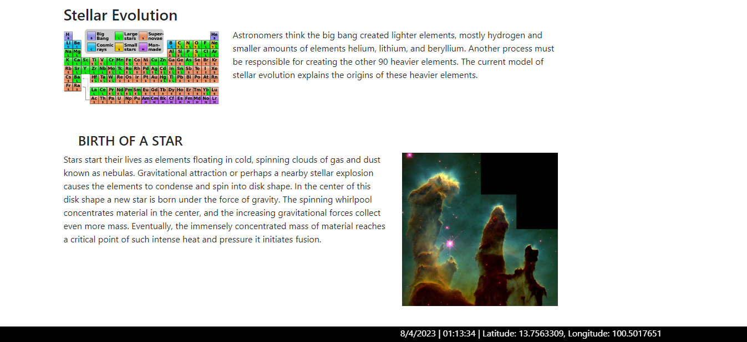

### Contact Us

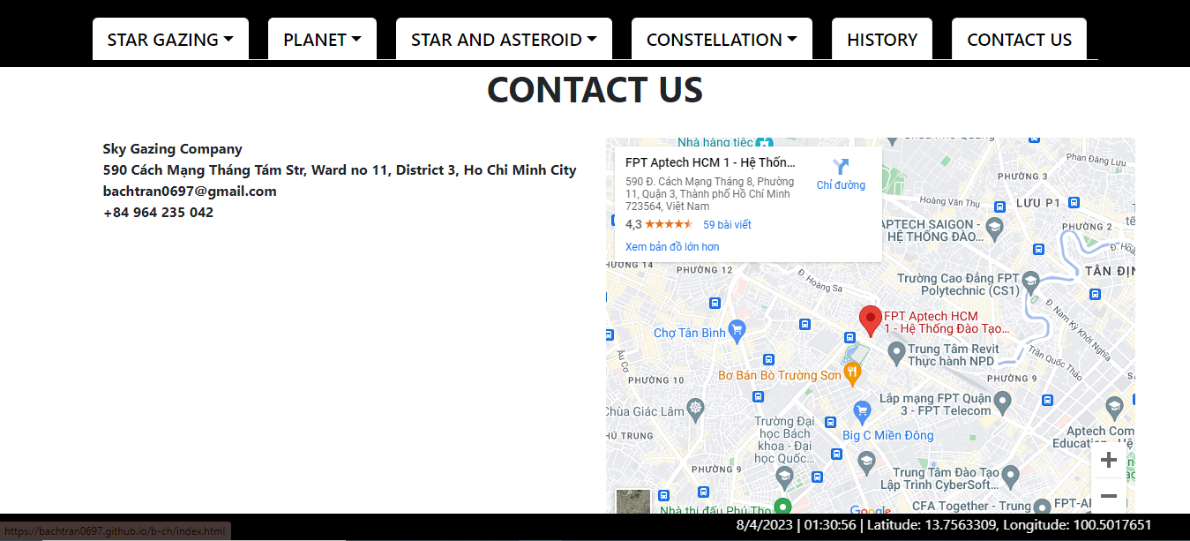

## Task Sheet

|  |  |  |  |  |  |  |
| --- | --- | --- | --- | --- | --- | --- |
| **Project Ref No.** | **Project Title – Ask Me Mobile** | **Activity Plan Prepared by** | **Date of preparation of Activity Plan** | | | |
| **Task** | **Actual Start Date** | **Actual Days** | **Teammate Names** | **Status** |
| Brainstorming ideas for layouts and Project Object | | Bách, Nhân, Dũng, Bảo | 11/03/2023 | 1 days | Bách, Nhân, Dũng, Bảo | Completed |
| Draw site maps and architecture design | | Bách, Nhân, Dũng, Bảo | 11/03/2023 | 1 days | Bách, Nhân, Dũng, Bảo | Completed |
| Wire framing general page layout | | Bách | 13/03/2023 | 3 days | Bách | Completed |
| Collect static assets (pictures, mp4, documentation,…) | | Bách, Nhân, Dũng, Bảo | 13/03/2023 | 8 days | Bách, Nhân, Dũng, Bảo | Completed |
| Design & Build Homepage | | Bách, Nhân | 17/03/2023 | 9 days | Bách, Nhân | Completed |
| Design & Build Star Gazing | | Bách | 17/03/2023 | 14 days | Bách | Completed |
| Design & Build Planet | | Nhân | 17/03/2023 | 14 days | Nhân | Completed |
| Design & Build Star and Asteroid | | Bách, Dũng | 20/03/2023 | 14 days | Bách, Dũng | Completed |
| Design & Build Constellation | | Bách,  Bảo | 20/03/2023 | 14 days | Bách,  Bảo | Completed |
| Design & Build History | | Bách, Dũng | 20/03/2023 | 14 days | Bách, Dũng | Completed |
| Design & Build Contact | | Bách | 20/03/2023 | 14 days | Bách | Completed |
| Javascript | | Bách | 17/03/2023 | 5 days | Bách | Completed |
| Write Project Report | | Bách | 09/04/2023 | 2 days | Bách | Completed |

## Testing document

|  |  |  |  |  |
| --- | --- | --- | --- | --- |
| **Sr.No** | **Features Tested** | | | **Remarks** |
| 1 | Are all the users able to view the images and links? | | | OK |
| 2 | Have all the views, modules and controllers been | |  | OK |
| properly integrated and is the site function as a single | | |
| page application? | |  |
| 3 | Are the GUI content devoid of spelling mistakes? | | | OK |
| 4 | Is the application user-friendly? | | | OK |
| 5 | Is the Website launching correctly in all popular | |  | OK |
| browsers? |  |  |
| 6 | Do all text links lead to the appropriate website? | | | OK |
| 7 | Do all image links lead to the appropriate website? | | | OK |
| 8 | Are all the images and links clearly visible on the page? | | | OK |
| 9 | Does the Web page work properly in all the tested | |  | OK |
| browsers? |  |  |
| 10 | Does the Web page take too long to be loaded fully? | | | OK |
| 11 | Is the navigation sequences correct through all the Web | | | OK |
| pages on the site? | |  |
| 12 | Is the JavaScript code working as expected in all click | | | OK |

## Final checklist

|  |  |  |  |  |
| --- | --- | --- | --- | --- |
| **Sr.No** | **Features Tested** | | | **Remarks** |
| 1 | Are all the users able to view the images and links? | | | OK |
| 2 | Have all the views, modules and controllers been | |  | OK |
| properly integrated and is the site function as a single | | |
| page application? | |  |
| 3 | Are the GUI content devoid of spelling mistakes? | | | OK |
| 4 | Is the application user-friendly? | | | OK |
| 5 | Is the Website launching correctly in all popular | |  | OK |
| browsers? |  |  |
| 6 | Do all text links lead to the appropriate website? | | | OK |
| 7 | Do all image links lead to the appropriate website? | | | OK |
| 8 | Are all the images and links clearly visible on the page? | | | OK |
| 9 | Does the Web page work properly in all the tested | |  | OK |
| browsers? |  |  |
| 10 | Does the Web page take too long to be loaded fully? | | | OK |
| 11 | Is the navigation sequences correct through all the Web | | | OK |
| pages on the site? | |  |
| 12 | Is the JavaScript code working as expected in all click | | | OK |